**Experiment 03 (Cyber Security Workshop Lab)**

**Protocol Hierarchy:**

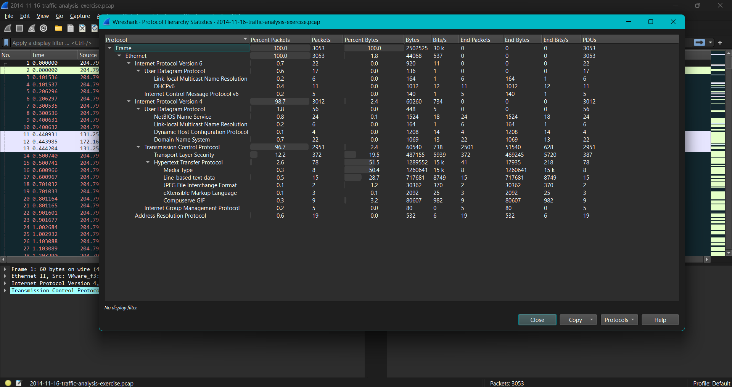

**Filter:http.request**

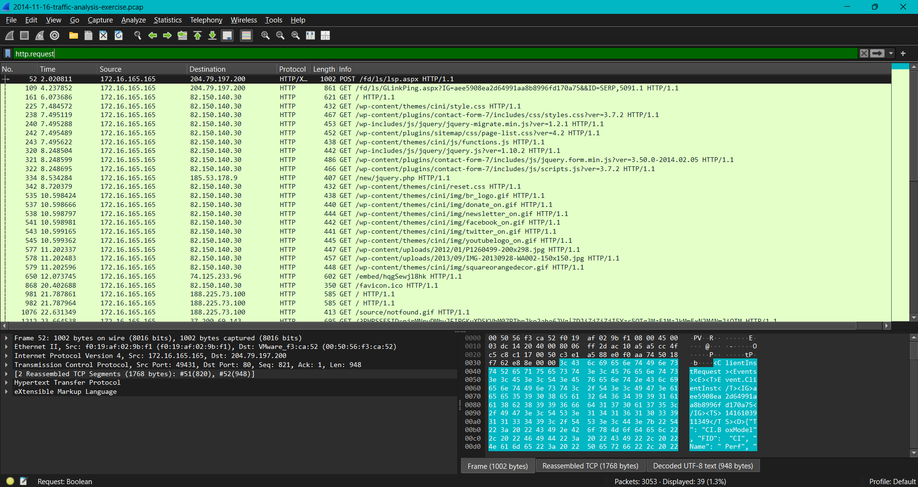

**Check Host Column:**

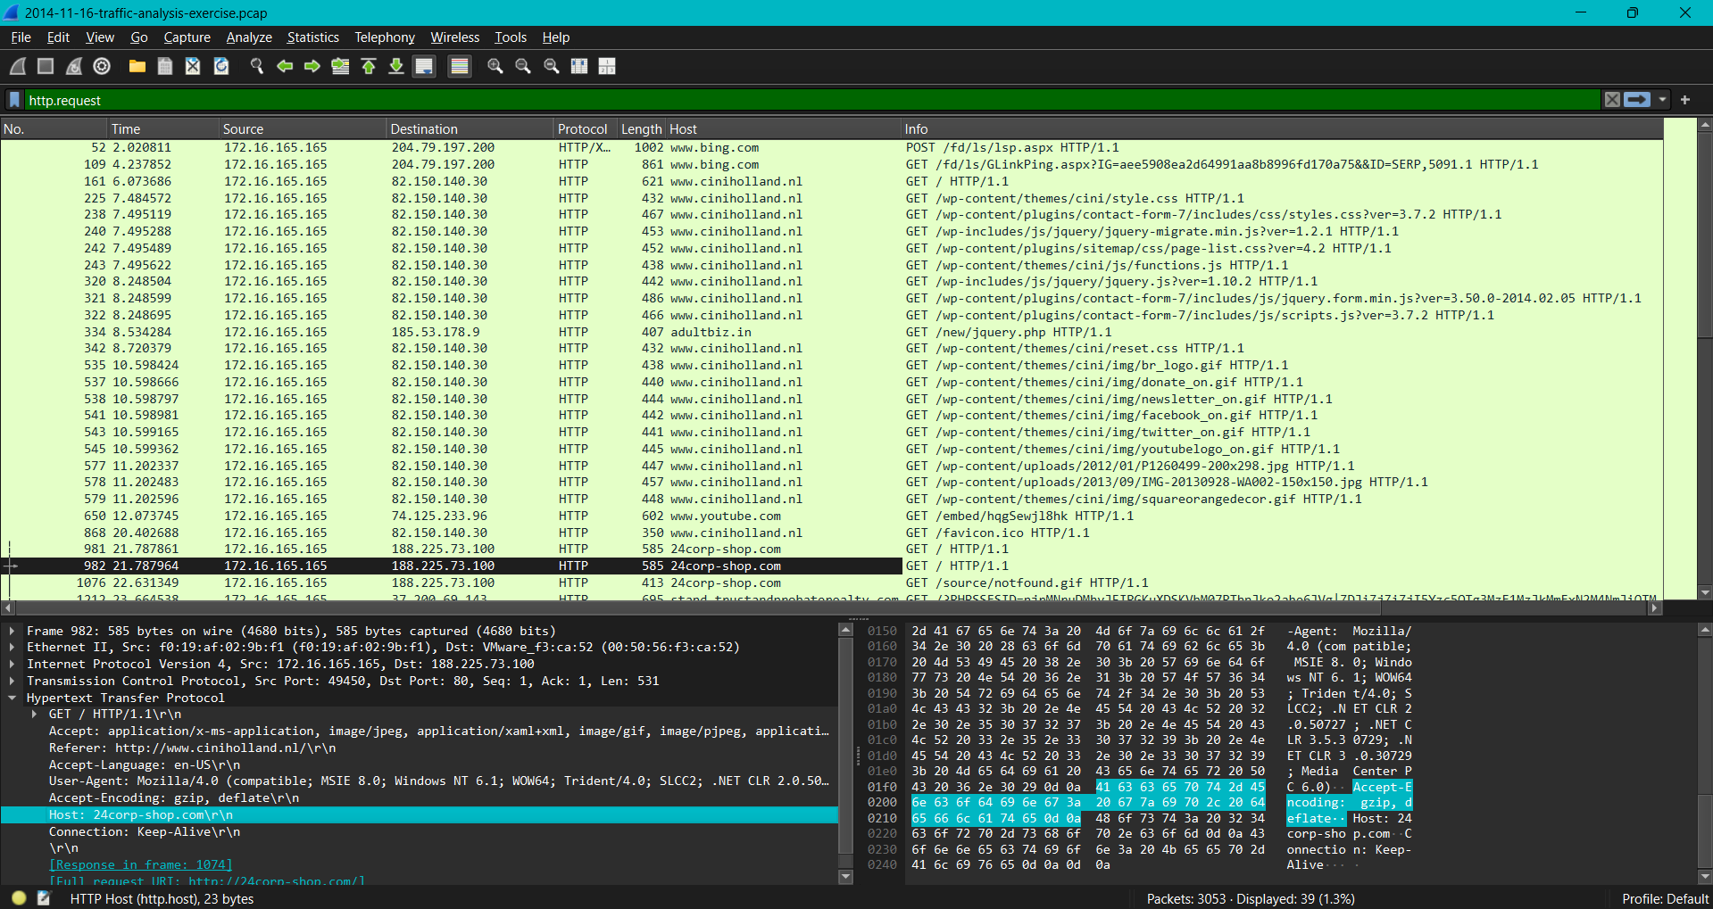

**Sort column by Content type:**

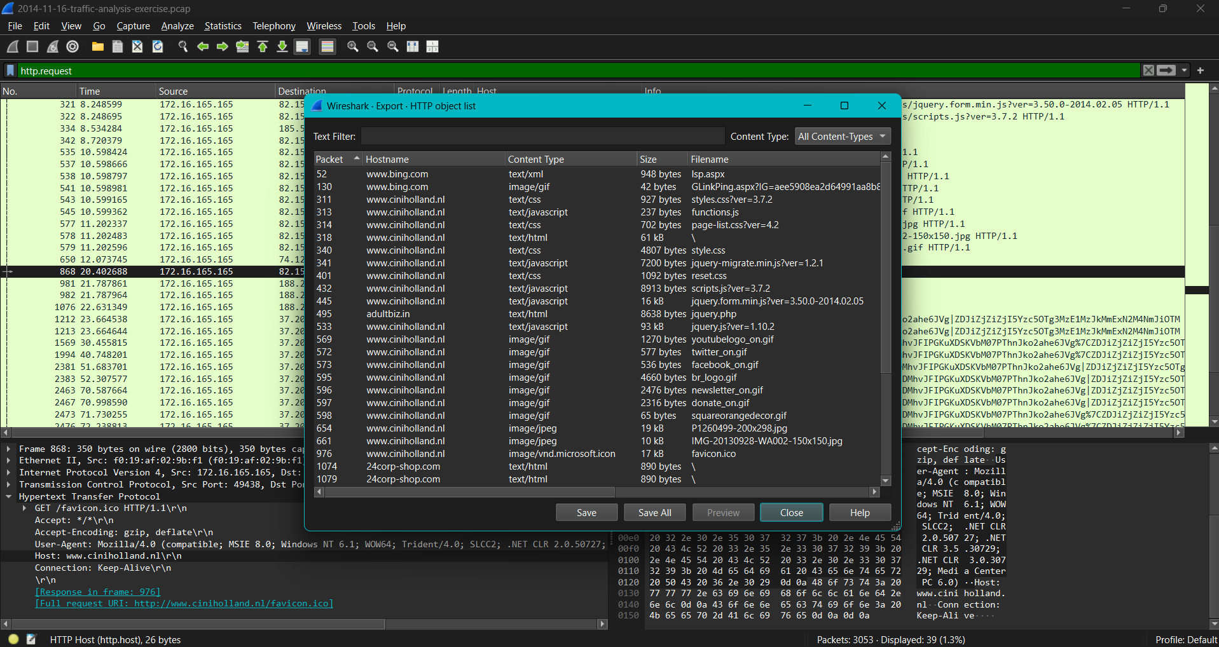

**Save all suspicious files:**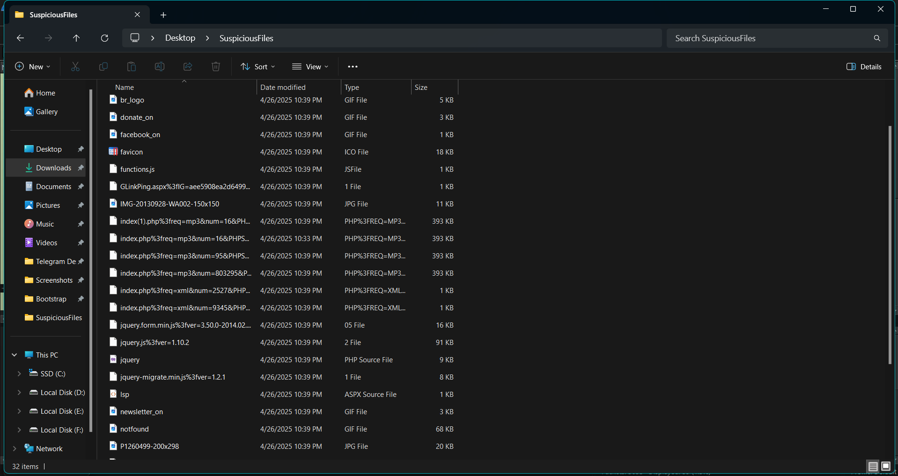

**Hash value Generation:**

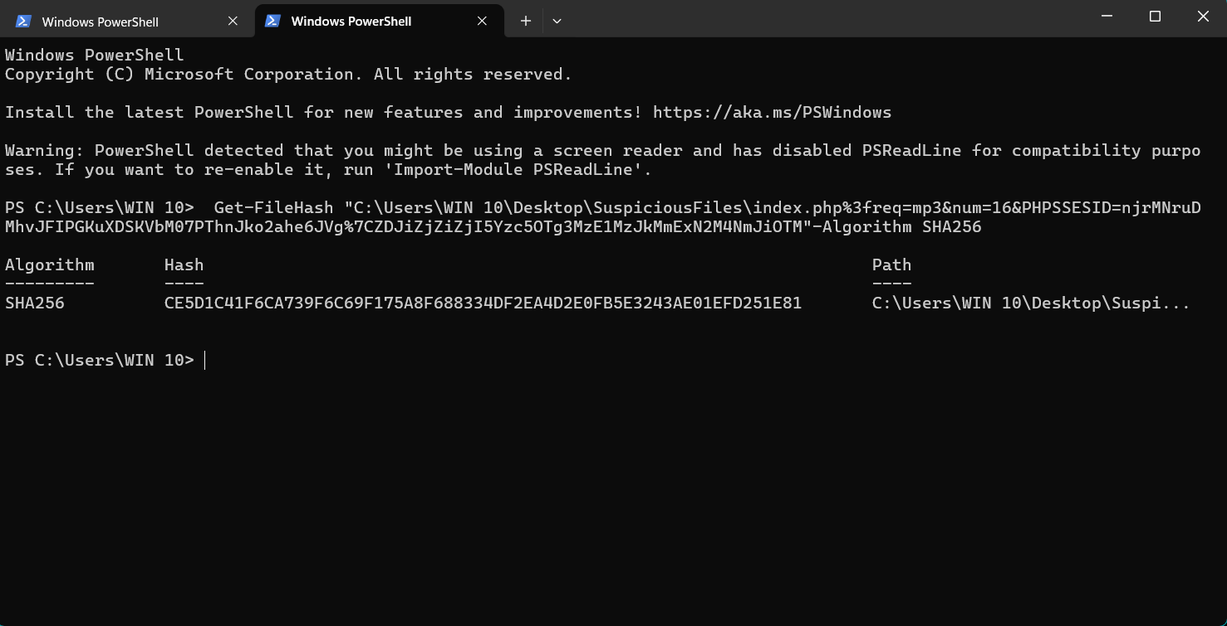

**Virus Total Visit:**

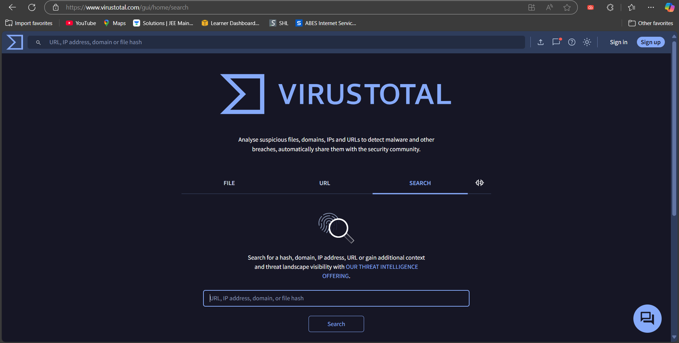

**Malicious or Benign Detection:** 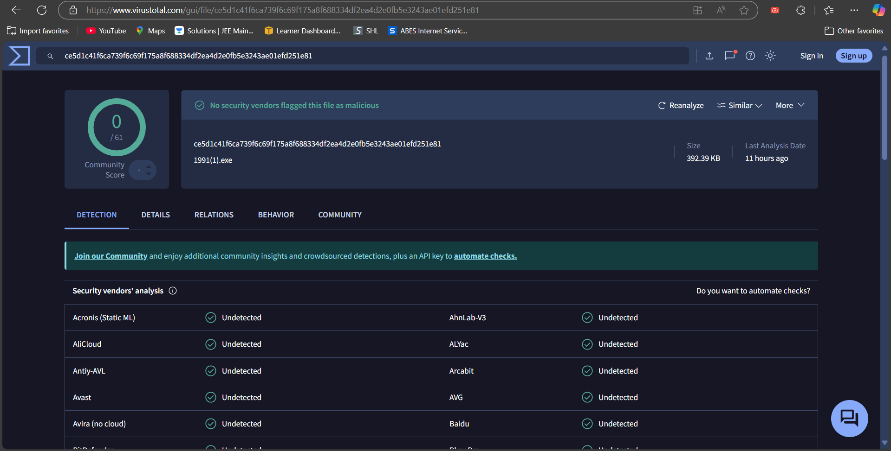

**Taking Random Hash Value From Internet:**

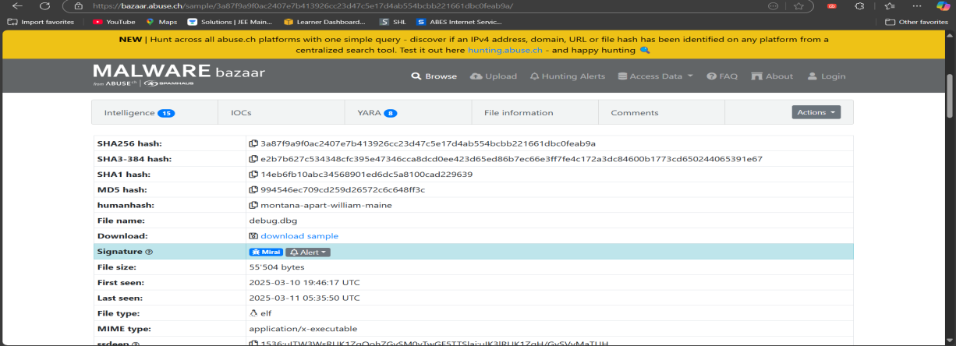

**Malicious or Benign**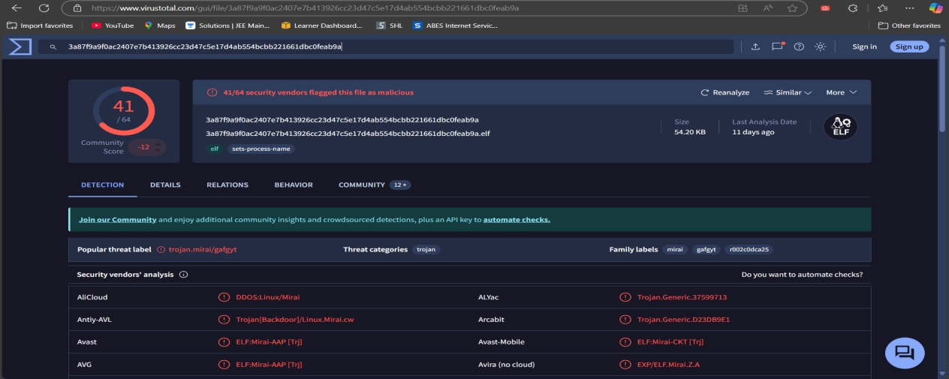

**Host name using DHCP:**

